Apple App Store Assignment - 2

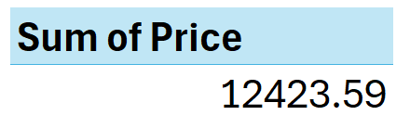Total price

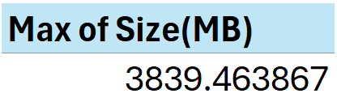Max Size Bytes

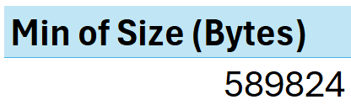 Min Bytes Size

Distinct Apps

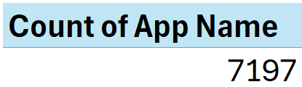

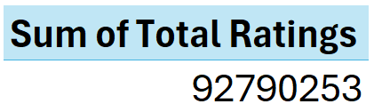Total ratings

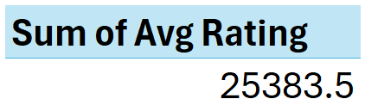Avg. ratings

Analysis which has been done -

* 1. Top 5 Apps by Total Bytes and prices

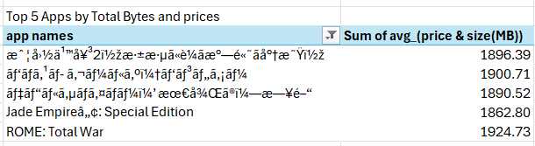

* 1. Top 5 Primary Genre by Avg Ratings

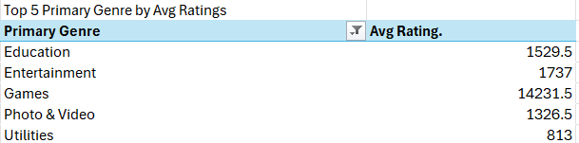

* 1. Top and Bottom 10 Apps by supported languages

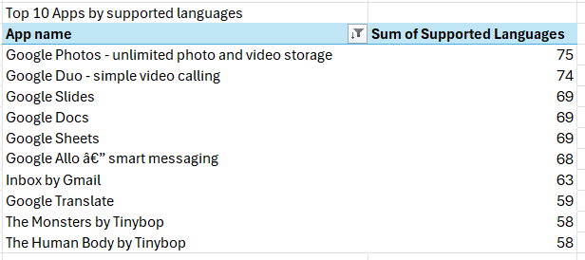

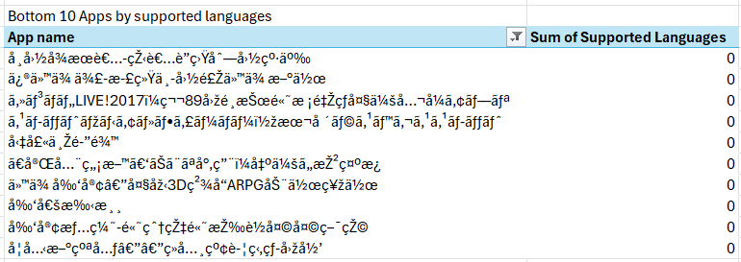

* 1. Top 5 Apps by Avg rating and Current version Av ratings.

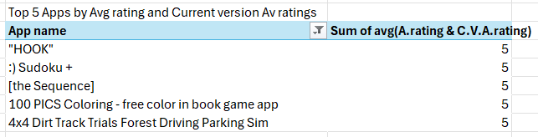

* 1. Age group and Bytes group wise Analysis (Price and Total ratings)

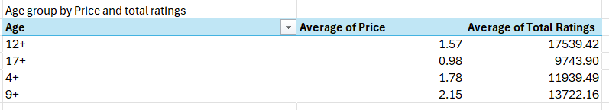

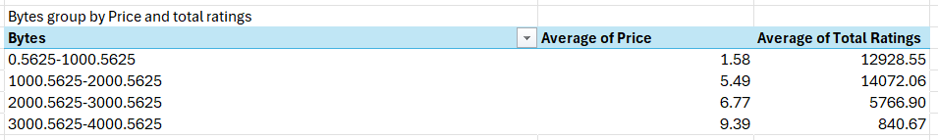

* 1. Create a Slicer on Supported Devices and Number of Screenshots.

